GIT & GITBASH
Git –version – We can check the version
ls – list of files
git status – To check the status of our repository
git init -Creates .git folder
.git directory stores configuration

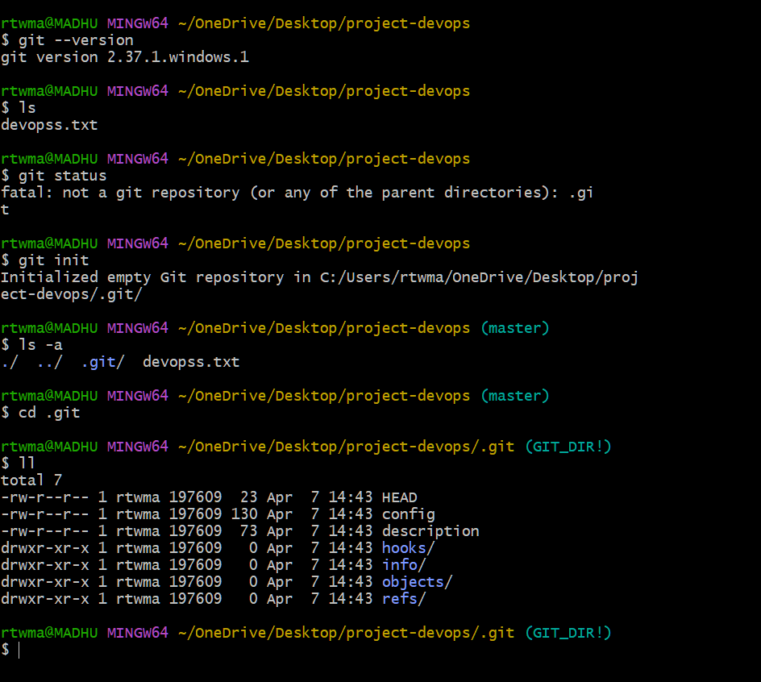

Created a file m
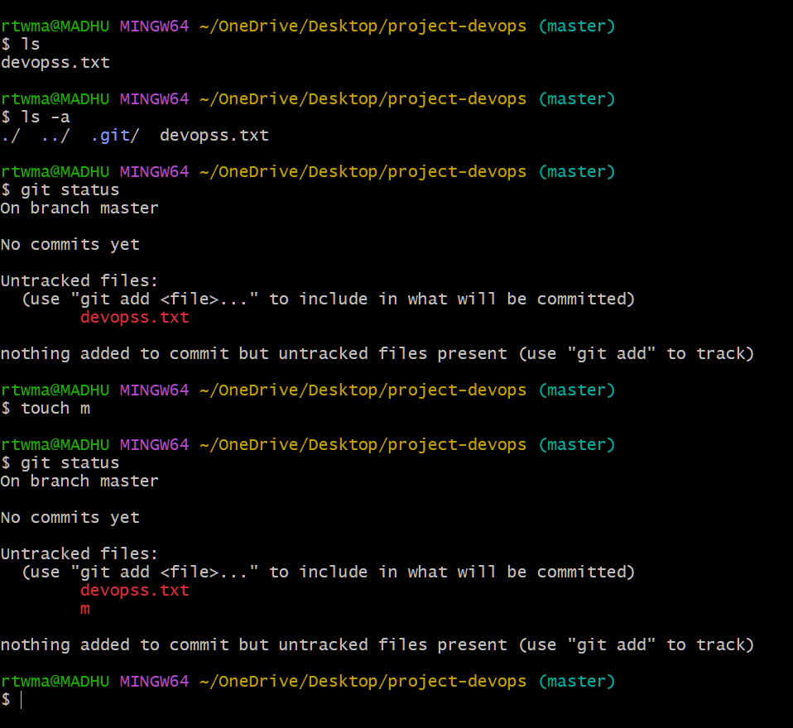

Removing .git deletes all version control history and makes the project no longer a Git repository
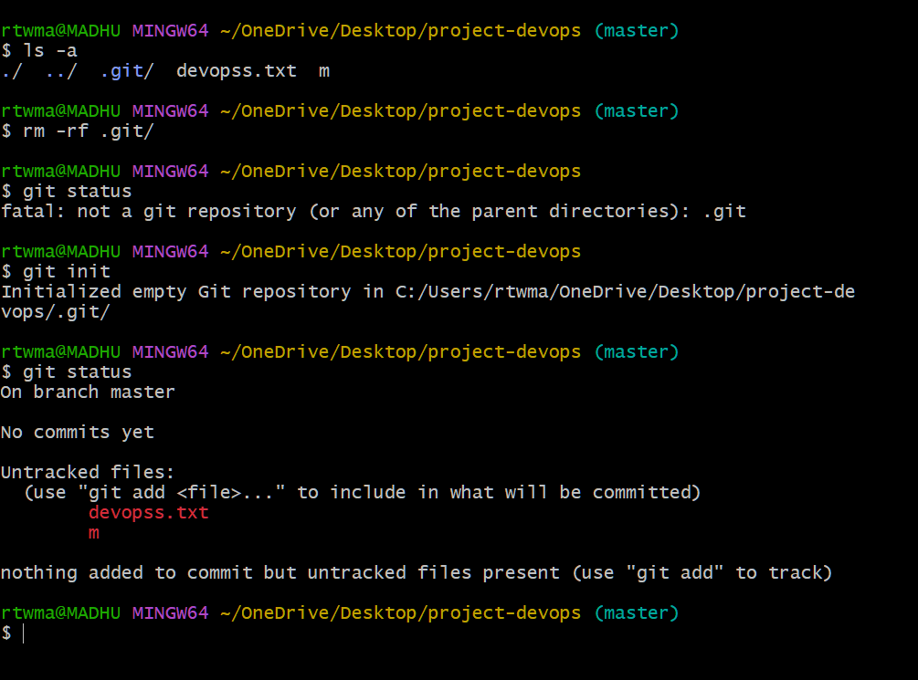

git config –list : It will help us to get all the details like userdetails,username and default details
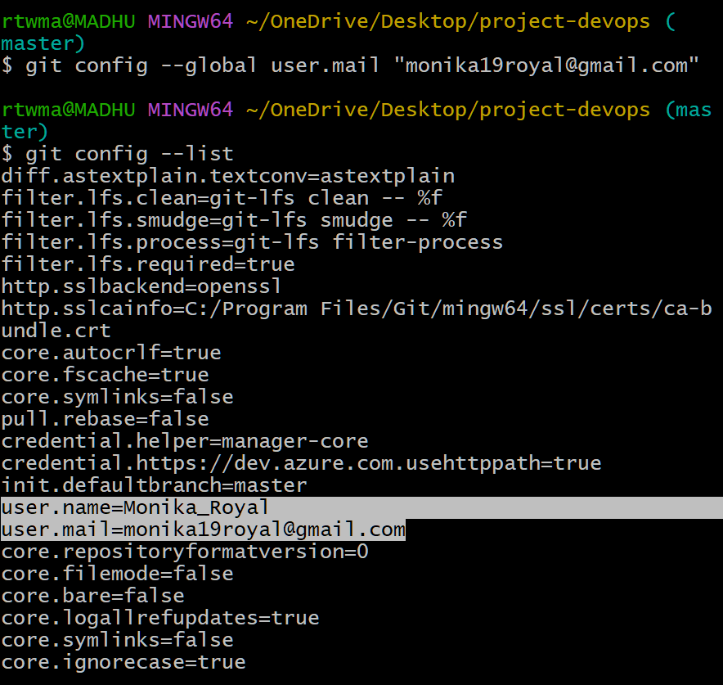
git add filename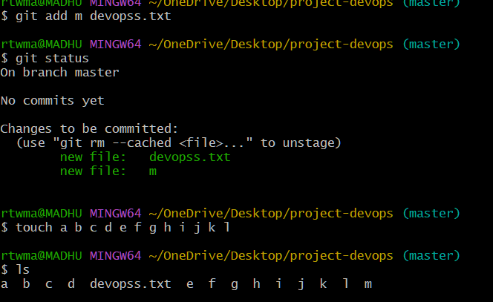

To add multiple files to tracking are we use “.”
Git add .
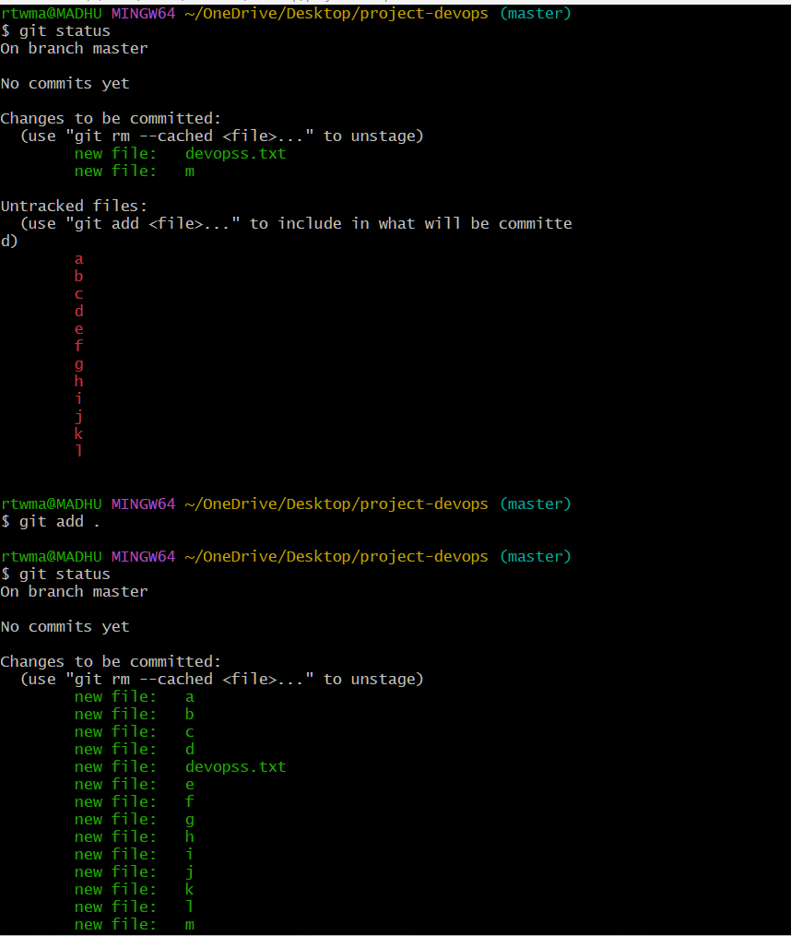

git status – To check the status of our repository like what changes we have made and how many files are added.
Git commit -m “message” origin – Changes made will be tracked or committed

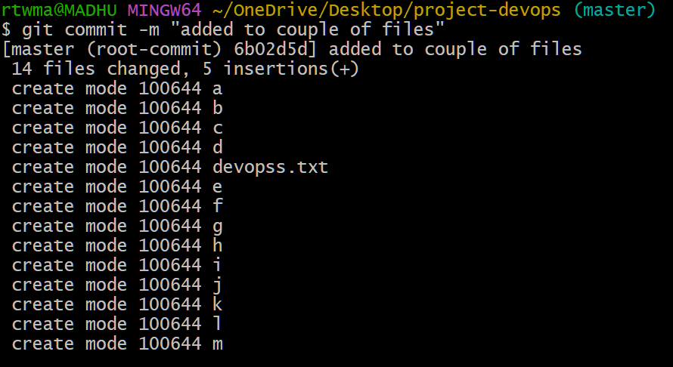

git add . :- Adds all files from working directory to staging area
git log:- Shows commit history with details like commit ID, author, and message
git remote :- Lists the names of remote repositories connected to your project

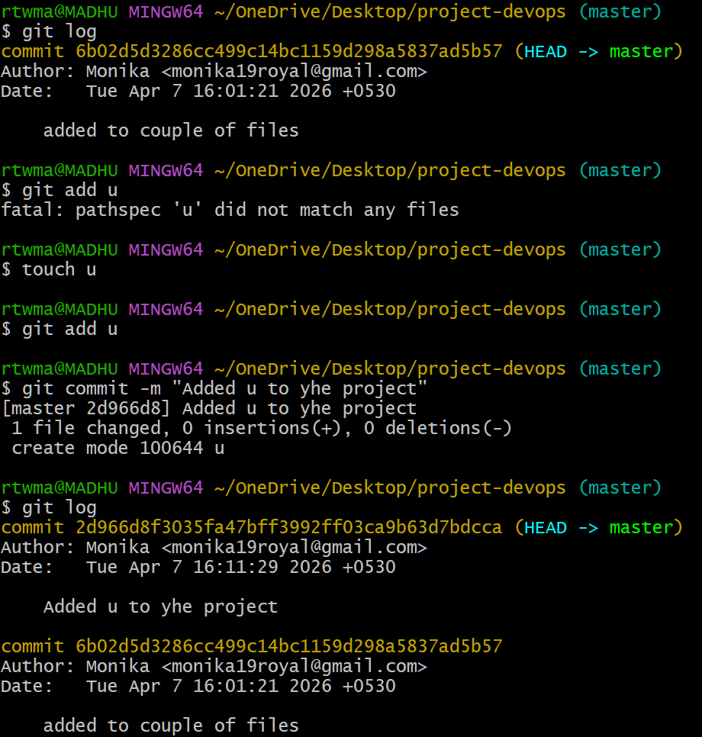
git remote -v :-Displays the remote repository names along with their fetch and push URLs.

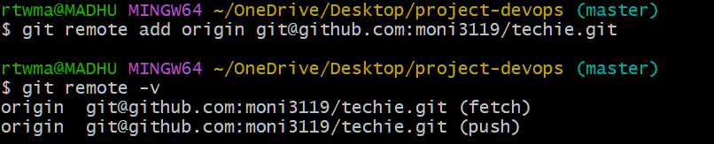
ssh-keygen:- Generates SSH key pair for secure authentication with remote repositories like GitHub

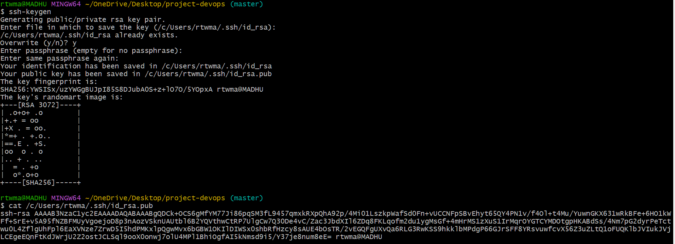
Click on settings select ssh and gpg key click on new ssh keyadd title Add keygen

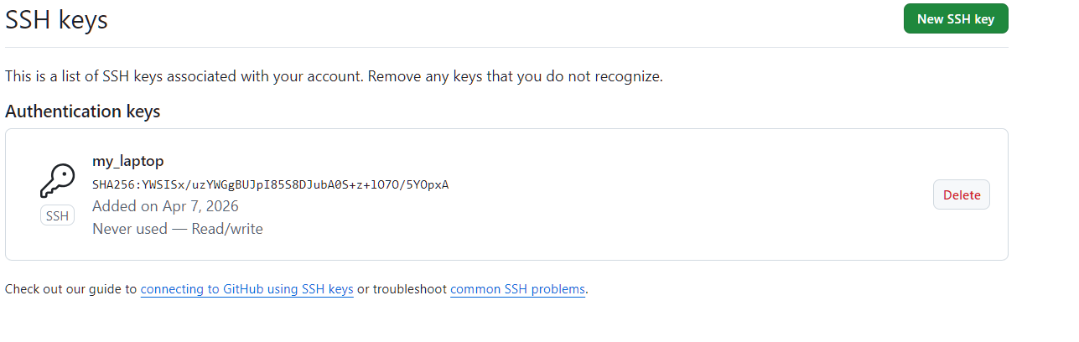
git push -u origin master :-Pushes code to the remote repository and sets the upstream branch for future pushes
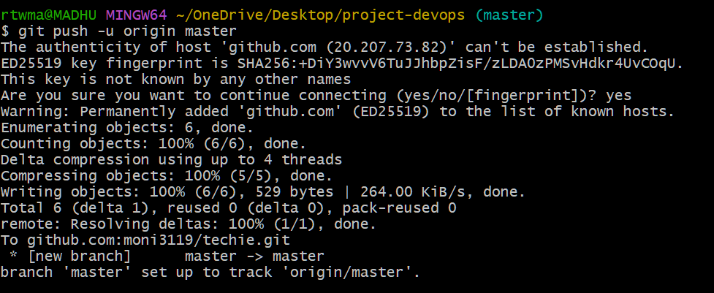
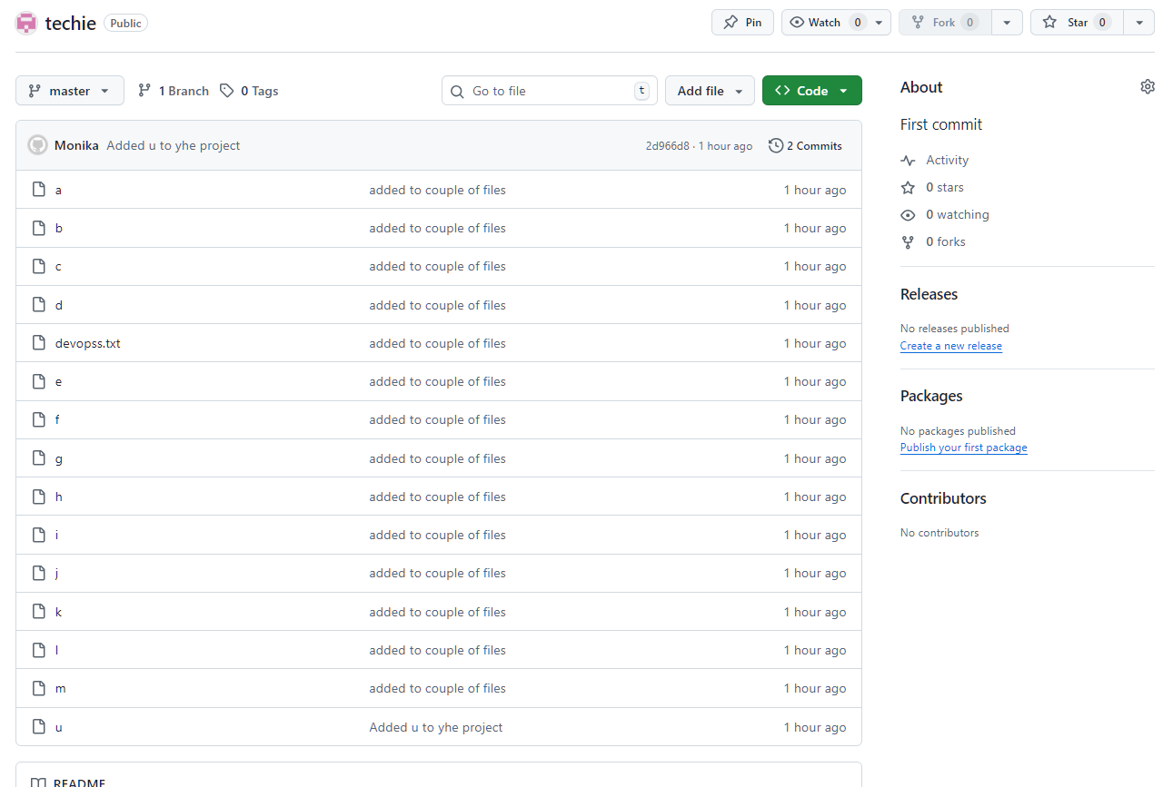

rm filename – To delete file
git commit -m "deleted e" :-Saves the changes locally with a message indicating file e was deleted
git push -u origin master:- Pushes the committed changes to the remote repository and sets upstream tracking

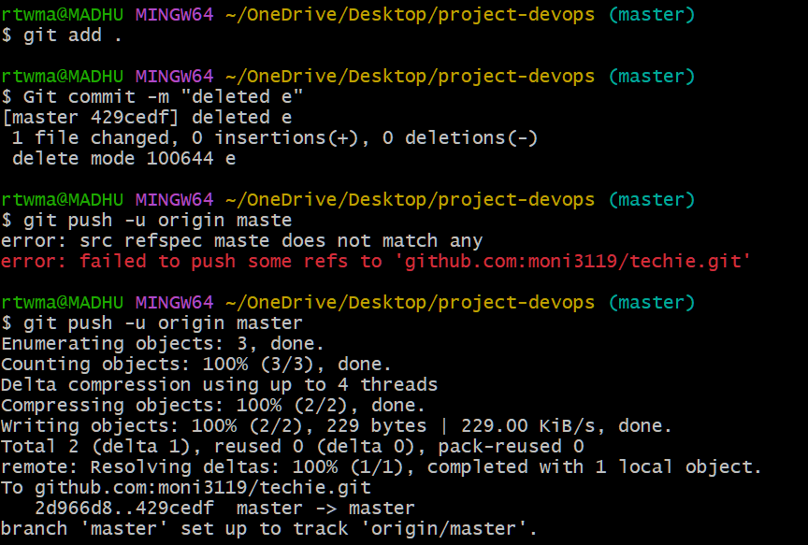
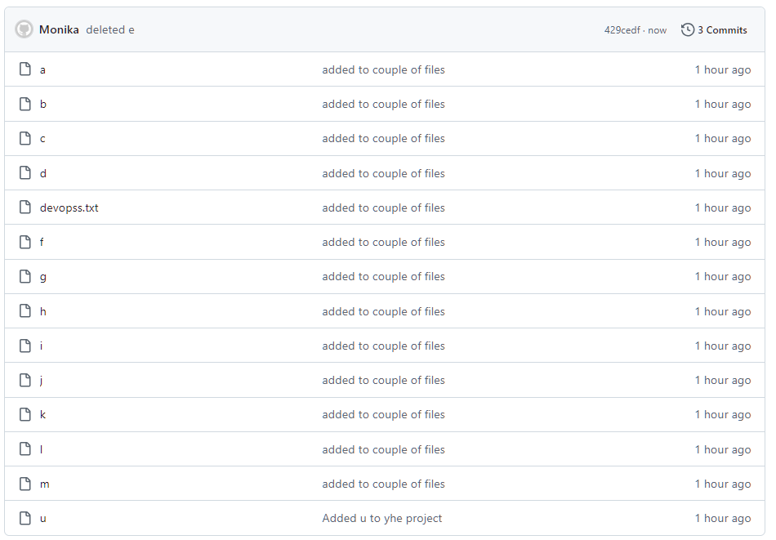

git pull – It will pull the changes from the central repository to local machine
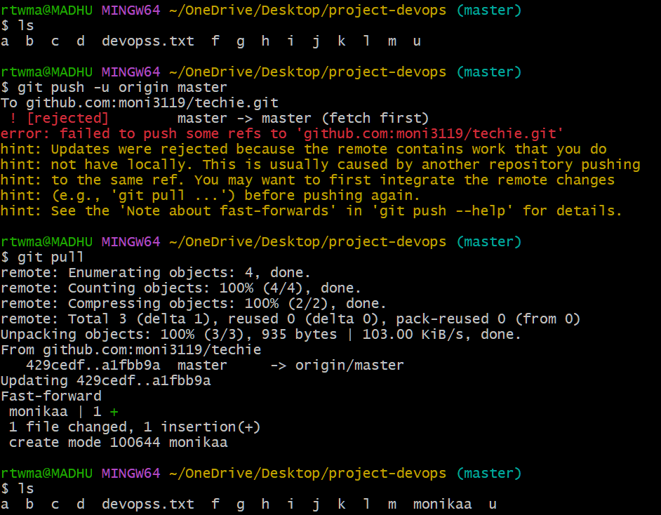
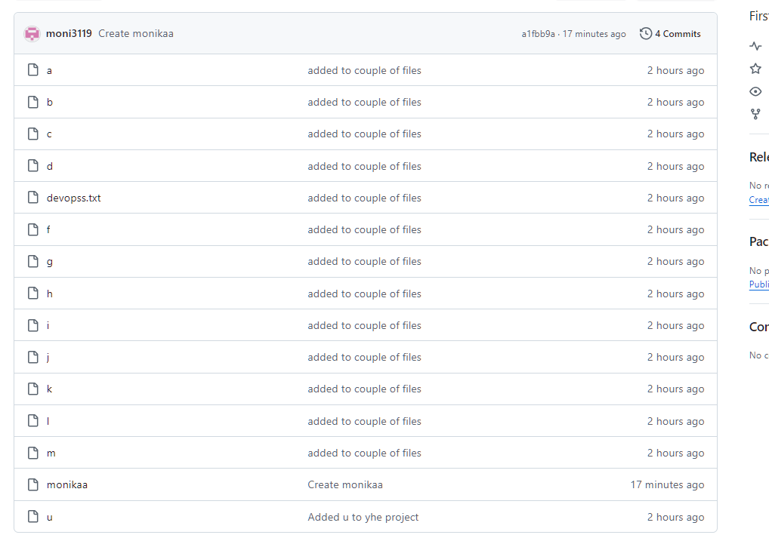

git clone:- Copies the entire repository from central (like GitHub) to local machine and creates a new directory
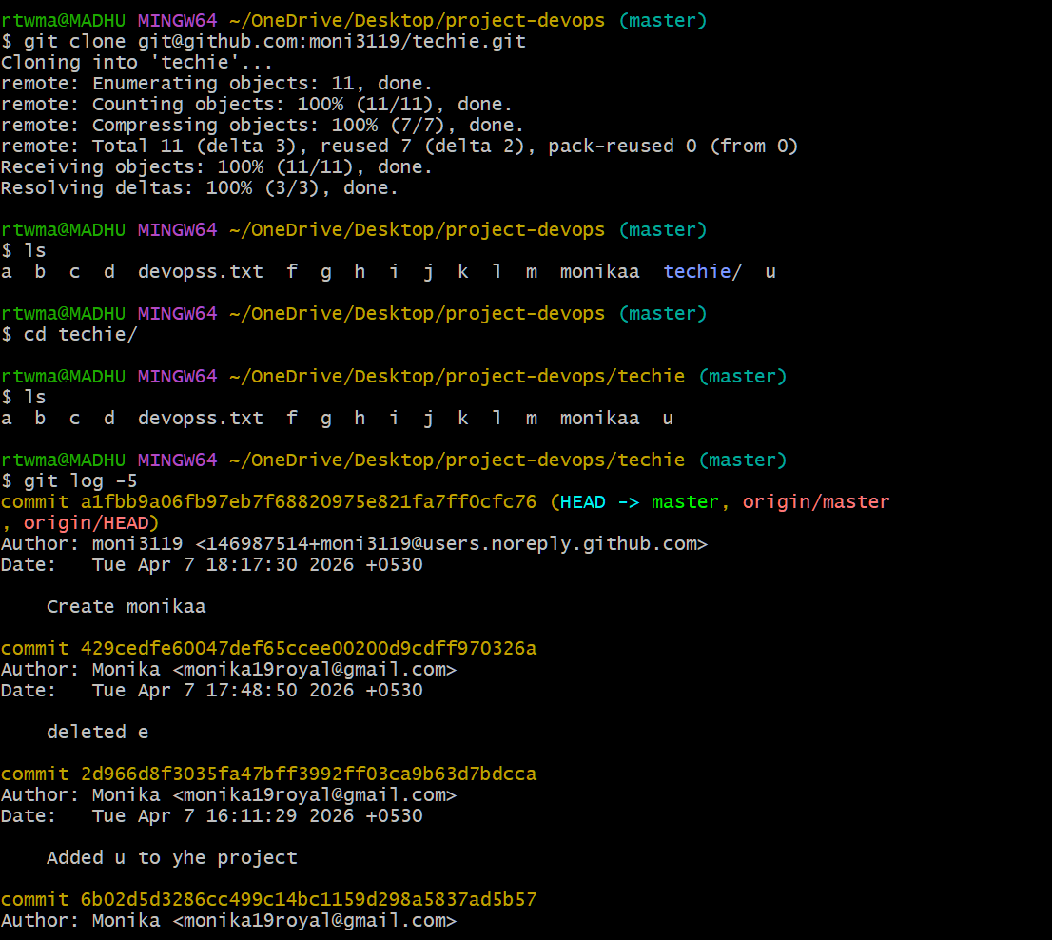
git revert :- Creates a new commit that undoes changes of a specific commit

